

College of Science and Technology

School of Science and Technology

# SOFT30121: Advanced Analysis and Design

# Systems Analysis Design and Implementation

*By*

N0683858: Hamid Mujtaba

T0084963: Haowei Goh

N0688119: Elliot Harding

N0756079: Steffan Walker

N0704050: Michael Abraham

N0772082: Hamed

NTU Stores Management System

SOFT30121: Advanced Analysis and Design i

Systems Analysis Design and Implementation i

1. Introduction 4

1.1. Purpose 4

1.2. User Characteristics 4

1.3. Assumptions 4

1.4. Scope and Constraints 4

1.5. Glossary of terms 4

1.6. Overview 4

2. Functional Requirements 5

2.1. Feature 1 5

3. Non-Functional Requirements 6

3.1. Usability requirements 6

3.2. Reliability requirements 6

3.3. Performance requirements 6

4. Interfaces 7

4.1. User interfaces 7

4.2. Hardware interfaces 7

4.3. Software interfaces 7

5. Use Case Modelling 8

5.1. Use Cases 8

5.2. Misuse cases 8

6. Project Plan: 9

References 10

7. 10

Bibliography 10

8. 10

# Introduction

## Purpose

Specify the purpose of this Software Requirements Specification. The SRS fully describes the external behaviour of the application or subsystem identified. It also describes non-functional requirements, design constraints, and other factors necessary to provide a complete and comprehensive description of the requirements for the software.

The purpose of this Software Requirements Specification document is to propose a system which will help the NTU staff to manage the stores. They currently do not possess a system which allows them to monitor the quantity of the products being consumed or to allow the (consumer) staffs to efficiently take the products. Instead, they write down the details on a piece of paper, from which the data is manually stored in 2 separate systems by the management staff; QuickBooks, which is responsible for creating an invoice for each department, and Sage, to update the database. The 2 systems mentioned are difficult to use, in addition to being time consuming and lack a lot of features making it hard for the staff to manage the stores. The proposed system will overcome this by combining Sage and QuickBooks along with providing additional features, such as the functionality to scan the products using external hardware, which will make it easier for the consumer staff to take items and the management staff to manage, as the system will update the database automatically.

The system is required to be able to; manage sock, create invoice for each department, create log of products taken by (which) staff, have unit of conversion between the unit supplied into the amount consumed, add new products on the catalogue, register products received from shipments, provide directions to help staff find items, notify the staff about important events, such as low stock, or shipment date. The system will deploy a very simple, easy to use UI with minimal input which will require no prior knowledge on using management systems. It will also provide staff with a ‘basket’ feature which will allow them to take bulk of items at once. There will also be an option for returning items, so if staff accidently took more than required, they can simply decrease the quantity on the checkout interface. The catalogue will have pictures with a brief description of the items to help consumer staff identify them easily. All the data will be backed up on an external (cloud-based) database to avoid data loss.

## User Characteristics

Create general customer profiles for each type of user who will be using the product. Profiles should include:

· Student/faculty/staff/other

· Experience

· Technical expertise

· Other general characteristics that may influence the product

The proposed product management system will include three kinds of users. The system privileges/features available to each of these will vary, as will their experience and knowledge of product management. The three types of users will include:

**Consumer**

The consumers will be comprised of university researchers/lectures who require the products available at the store. These users will be limited to removing and returning products to the store. They will not require much experience with virtual systems due to their limited usage of the system and the intuitive user interface which will walk them through the product removal process. The consumers will only need to understand the basic fundamentals of computer usage and graphical user interfaces in order to utilise the system. Interface basics such as clicking a plus to increment the quantity of a product, back arrow to move to the previous page etc. will be all that is needed of this user.

**Staff**

The staff will be the employees working in the store that are in charge of managing stock, receiving shipments and assisting consumers. This type of user will have greater system privileges than the consumer as they will be responsible for the systems store management features. The proposed system is designed to automate a large amount of the manual work needed in the current system and as such the work load is lessened. However, the staff will still be required to input data into the system such as shipment codes so that the system can update the log and the stock database. This will require staff to have some experience with data input in addition to graphical user interfaces. Experience with systems such as MS Excel will transfer easily to the proposed system.

**Admin**

The admin will be the store employees that have greater control over how the store is managed and run. The admin users will be responsible for managing the catalogue of items available to the consumers in addition to viewing logs of removed products and received shipments. Because admins will have greater control over the store as a whole, they will require management and stock control experience in order to fully utilise the system. The level of technical expertise will be similar to that of the staff.

## Assumptions

List any assumptions that affect the requirements, for example, equipment availability, user expertise, etc. For example, a specific operating system is assumed to be available; if the operating system is not available, the Requirements Specification would then have to change accordingly.

## Scope and Constraints

A brief description of the software application that the Software Requirements Specification applies to.

Also describe any items that will constrain the design options, including

· Parallel operation with an old system

· Audit functions (audit trail, log files, etc.)

· Access, management and security

· Criticality of the application

· System resource constraints (e.g., limits on disk space or other hardware limitations)

Other design constraints (e.g., design or other standards, such as programming language or framework)

* + 1. **Scope**

This is a program for small and medium enterprises to do data storage management. The software application applies a software development environment, databases and platforms.

The software development environment (SDE) is using Visual Studio. C# is our main language to coding backstage such as input, output, verification and button access. It’s a programming language designed with the first “component-oriented” language and discourages or prevents type errors. NET framework is intended to be used by the newest application created for the Windows platform. (Dhall & Sundararaman, NA). So, we decided using C# .NET to develop our application interface. MySQL is a high performance and the flexibility of open source. Moreover, it’s free software for us to build our system.

MySQL is not the only database on this program. Another database will build for backup data on the cloud might be Firebase or Amazon Web Service. Cloud database is based on one Real-time Database illustration and consequently getting updates with the most current data. It is built for application developers by cloud storage, a capable, basic and cost-effective object storage service.

The system that we build must consider the platform with is phone, tablet and computer system. Phone and tablet need to support Android and IOS system. For the PC, it is a web page or an application?

* + 1. **Constraints**

No matter in the processing of the program or after the program is developed, we will meet some difficulties. 'How can a company modify our program' is the first problem.

Firstly, the database. The challenges of the database are different database systems and database formats. The familiar database systems have MySQL, Oracle, CVS, etc. and common database formats have XML, JSON, CSV, etc.. The conversion between these database systems and database formats is a problem for us.

Secondly, the audit file access policy needs to select multiple security audit policies as needed. Operating system record the accessed information in the security log, including the access personnel, visitor's computer, and access time. All of them are entering the log will not easy to maintain and manage. The capacity will be occupied by unnecessary log files.

Thirdly, implementation, management and security can only be carried out smoothly with a comprehensive system. On the implementation part, the delay between data transfer, access time and different devices might cause the system to have a different operation. In terms of management, the staff assignment, goals and planning are important reasons for success or failure. For security, the company's product data how can be ensured in every time. How can reduce or avoid the number inputted is wrong?

The limitation of system resources is the size of the disk space. Because of the constant record of picking up, receipts and other information will take up a lot of space. Besides, due to the size of the screen, there is a limited number of things that can be viewed at one time. The size of the RAM can affect the operation of the system. Because the same list display and storage will continue to find out the status of the card machine.

## Glossary of terms

Outline any acronyms, abbreviations and definitions that will be used throughout the document

## Overview

What does the rest of this document contain/how is it organised?

# Functional Requirements

These should be described in enough detail for the designers to design a system satisfying the requirements. These should also be testable.

They should also be organised appropriately (could be by feature) and prioritized (could be by MoSCoW).

A good requirement is:

* Correct
* Unambiguous
* Complete
* Consistent
* Ranked for importance
* Verifiable
* Modifiable
* Doesn’t specify any particular design
* Traceable

Not all of the requirements above follow this. Also need ratings added to them.

Must

**2.1: Store the inventory of the store’s stock**

The system must utilise a database to store information on the products being sold, their quantities and the alpha codes used in store to uniquely identify products. This database should update in real time when products are removed from or returned to the store.

**2.2: Display currently available stock**

The system must display, in a catalogue style, the stock currently available in store. The information should include the products name, the products alpha code, a picture of the product and the quantity available.

**2.3: Use a virtual basket when buying products**

When consumers go to remove an item, it should be added to a virtual basket along with any other products they might want to remove. This basket can then be “Checked out” when the consumer leaves the store and the products removed be registered in the system. Before checking out, the consumer should be able to add and remove products they have in their basket.

**2.4: Allow products to be returned**

The system must allow products to be returned that have previously been removed from the store. When a product is returned it will be inspected by a staff member before the return is registered which in turn updates the stock, the log and the invoice.

**2.5: Log the removal and return of products**

The system must keep a log of what products have been removed/returned by storing the products name, product alpha code, date and time of occurrence, the individual involved and their department name.

**2.6: Allow catalogue of products to be changed**

The user with relevant privileges must be allowed to add new products and remove old ones from the stores catalogue of available products.

**2.7: Create invoices**

The system must create an invoice based on information of what products have been removed, the price of the products and the department which removed the product. The invoice should be created at the end of the month.

**2.8: Allow users to login to the system**

The system must facilitate logging in for three types of users. These users include:

* **Admin:**

All the privileges available to staff in addition to control over the catalogue

* **Staff:**

With ability to receive shipments and inspect returned items/shipments

* **Consumer:**

Only allowed to remove and return products from the store

Should

**2.9: Convert supplier units to consumable units**

The system should convert the unit a product is bought and received in, to the unit that the product is consumed in at the store.

E.g. 1 Box of pens should be converted into the number of individual pens a box contains as pens will be removed from store individually.

**2.10: Register received shipments**

The system should allow staff members to input shipment data, such as supplier codes and quantity, so that the store’s inventory updates with the stock contained in the shipment.

**2.11: Provide low stock warnings**

The system should notify staff members when the stock of a particular product is low so that more can be ordered in.

**2.12: Allow stock inspection**

Stock that has arrived from shipments or been returned by a consumer must be stored in an inspection database separate to general stock. When stock has been inspected by a staff member is will then be moved to the general stock database.

**2.13: Display tags for important information**

The system should display, on the product page, any important information relating to the product in question. Products which are toxic, explosive, radioactive or pose any kind of health risk should have this information displayed clearly and readily visible at the top of the product page.

**2.14: Track items that expire**

Products that can only remain on store shelves for so long should be tracked through the system so that when expiry dates are close, the staff members are notified and products with the soonest expiry can be placed at the front.

**2.15: Log received shipments**

When shipments are received and registered through the system, they should be logged in a database. The log should include the shipment’s Order Head with details about the shipment itself and the Order Line with details on the products and quantities included in the shipment.

Could

**2.16: Provide directions to products**

The system could display a map of the store with a marker indicating the location of the desired product within the store.

**2.17: Remind staff about deliveries**

The system could remind staff members with notifications about upcoming shipments/deliveries. The notifications would include the delivery’s time, products being delivered and any additional information such as whether special handling equipment is needed.

**2.18: Scan barcodes of products**

The system could allow users to scan barcodes of products to remove the need for manual input of data into the system. Barcodes would be scanned when consumers add products to the basket and when staff need to register received shipments as part of the store’s stock.

# Non-Functional Requirements

Describe the characteristics of the system. Explain the rationale of each of these to aid design choices later. Be as specific as possible. Not all these requirement types may apply, so only use ones appropriate the system.

From the description above the best approach seems to be a format for each requirement, with Explanation, Rational, and priority rating (from previous).

## Usability requirements

…

## Reliability requirements

…

## Performance requirements

…

* Store inventory of current stock

*This is currently implemented through Quickbooks. System should update stock in real time. (Current system only updates stock at then end of the month via invoice)*

* Create invoice

*This is currently implemented through Sage. The invoice should be created from data on what products have been taken, the quantity and the department they have been taken from.*

* Create log of products being taken

*Logging the products being taken, and who has taken them should allow to create an end of month invoice*

* Display currently available stock
* Unit Conversion (Boxes to Items)

*The system should convert the codes used by the supplier into an amount that is used by the system. E.g. a supplier code AGH43579 Could mean 1 box of 100 packs of individual pens.*

* Register products received from shipments

*The relevant staff members should be able to input the code used by the supplier which then updates the stores current inventory*

* Database to cross reference codes used by the store and the supplier

*The store uses alpha codes to identify specific products. A different code is used by the supplier to identify the products. The system should allow the admin/relevant staff member to input the suppliers code and have the inventory update with the relevant code used in store.*

* Provide directions through the store to a desired product

*Optional feature. Would be useful in particular when the store is busy. However is not a crucial part of the system.*

* System could remind relevant staff of when the next delivery is/details about what is being delivered.

*Optional feature. Not desired but would be useful for when customers require something out of stock and want to know when it will be back in*

* Return feature for products to be returned

*The feature should allow products to be returned which will then update the inventory and the corresponding invoice for the department that returned it.*

*Must be exclusive to staff members to avoid consumers returning damaged goods*

* VAT Option

*Must allow admin to select whether products being added to the catalogue have VAT or not*

* Allow admin to update the catalogue of items being sold

*The admin could have the ability to add/remove products that are being sold in the event new products are desired or old products need to be removed*

*(Ask Nigel)*

* Low quantity reminder

*The system should notify the relevant staff members that a products stock is low so that more can be ordered in*

* Log in

*Facilitate the login of an admin, staff member and regular consumer. Staff may update the inventory and receive shipments. Admin has more control over things such as the catalogue of items. Regular consumer may only take out and return items to the store. Apprentice’s cannot*

* Inspection Stock

*The system must store products in an inspection database first and can only be added as general stock after a staff member has inspected. Staff member can have ability to add products to the general stock after inspecting an item.*

* Bar Code Scanning

*To improve ease of use, a barcode scanner could be implemented that removed the need to input product data into the system manually.*

*Optional feature. Not necessary for system completion but would improve ease of use.*

* Product Tags/Categories

*The system should display important information for products that could be deemed dangerous such as toxic chemicals/explosive gases.*

* Basket System

*The consumer should be able to see their current items they plan to take out with pictures of the items, quantity, unit. They should be able to remove items and add new ones to their basket before they finalize their removal and “Checkout”. (System is very similar to the scan and go used at Tesco)*

*If barcode scanner is used this could update the basket by scanning multiple times for multiple items.*

* Track items that expire

*Certain items cannot remain on the shelf for certain periods of time and as such should be monitored and kept track of how long an item has left on the shelf.*

*(Ask Nigel)*

* Track Shipments Received

*Must include:*

*Order Head*

*Supplier Name*

*Supplier Site Name*

*Supplier Remit to address*

*Order Number*

*Order Date*

*Requested Date*

*Promised Date*

*Goods and Services Total*

*VAT*

*Invoice Total*

*Order Line*

*Supplier item number and/or universal product code*

*Item description*

*Quantity*

*Unit of Measure*

*Unit of Price*

*Extended Price*

*E5 will provide this information which the staff member must then input into the system to keep a log of the shipment.*

# Interfaces

Describe the logical characteristics of each interface between the software product and the users, and any external systems. This may include sample screen images (consider using balsamiq!), any GUI standards or product family style guides that are to be followed, screen layout constraints, standard buttons and functions (e.g., help) that will appear on every screen, keyboard shortcuts, error message display standards, and so on. Sections User interfaces, Software interfaces, Hardware interfaces.

**3.1 User interfaces**

Design

The user interface is to be designed in a simplistic manner in order reduce the learning curve of the system. Thanks to controls in the UI following a similar layout to similar existing systems, staff should have little difficulties transferring their knowledge of previously used systems.

Controls such as buttons will have black outlines to provide clarity in their purpose and location as well as allow colour blind users to distinguish them from other controls. Any of these controls which are used on multiple pages will be situated in the same location for each page to be consistent, reducing cognitive load for the user.

Most pages of the system will have a distinguishable help button. Clicking on this button will open a popup describing the purpose of the page and of any ambiguous elements it may contain.

Colour Palette

Surface & background colours

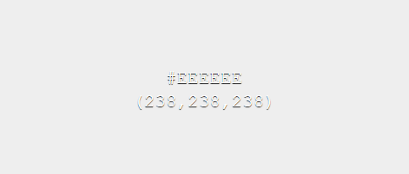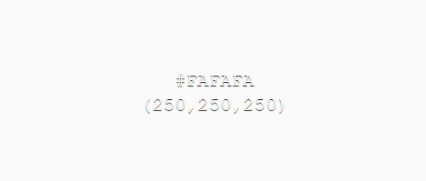

Error, message & action colours

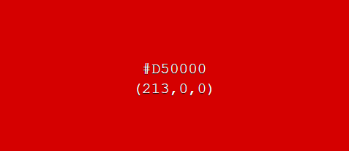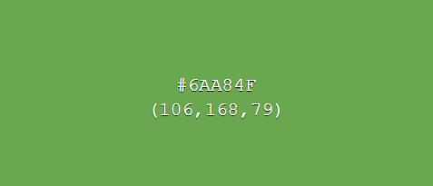

The chosen surface & background colours have been selected as weak toned colours as to not distract the user from more important UI elements. Two variants of the surface & background colours allow contrast between UI elements, such as distinguishing a background of a UI element and the system background, while keeping the same overall theme consistent.

In contrast, error, message and action colour tones have been chosen as bold colours, which draw users’ attention to important information.

GUI Mock-ups

Below are some example mark-up designs for how the system will look and act.

**Login page**

This page will be used by users to login to the system. An option for new users to sign up will also be available.

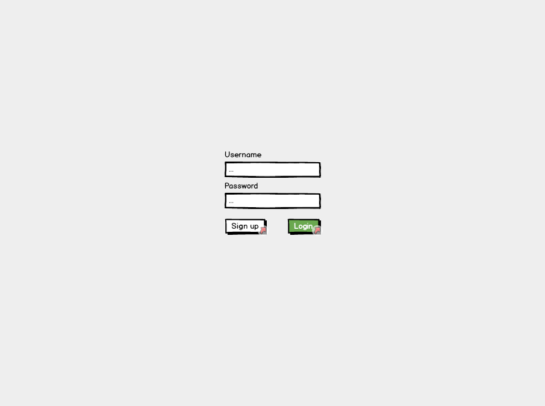

**Sign up page**

The sign-up page will be used by new users to sign up. Any disclaimer texts for users signing up will be displayed here. Users will be required to enter their N number so their account information can be linked with their NTU account.

Incentive for the creation of this page was in case a disclaimer was needed to be signed/read before users were able to use the stores.

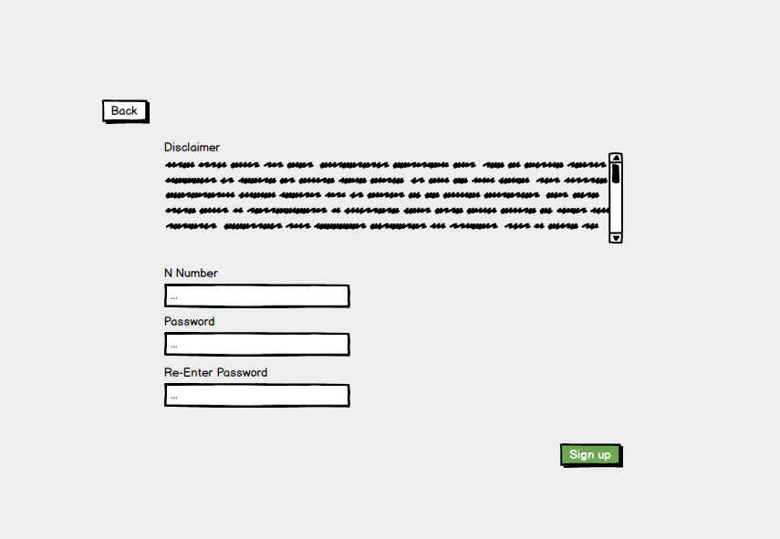

**Products page**

Once signed in users will be navigated to this page. From here products can be selected/searched for. A menu bar at the bottom of the page consistent across many screens will be available for navigating around the system.

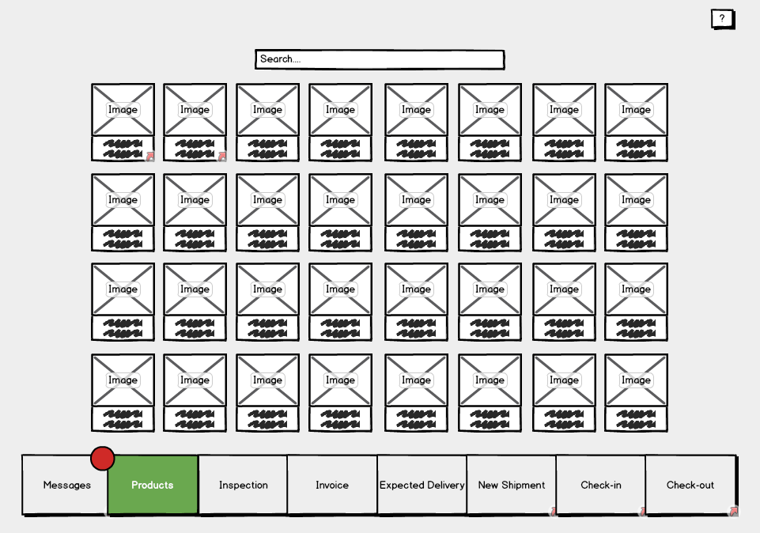

Users, as opposed to staff and admins, have less options and therefore their menu bar will be more simplistic.

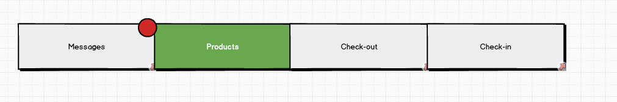

**Single product page**

This page will display the necessary information of a product. From here a user can add a product to their basket to checkout. A map of the location of the product within the store will also be available. If no items of the displayed product type are available users will be notified here as to when, if known, the next shipment of this product is expected.

This page will be navigable from various locations within the software in which products are shown.

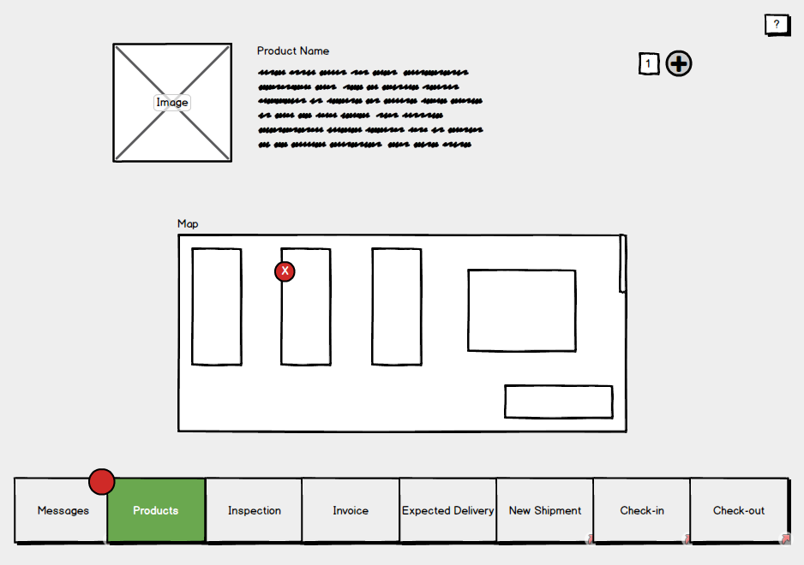

**Single product page (For staff & admins)**

Admins and staff will have access to more features on this page such as the ones shown below. Blue controls represent ones which only admins will be able to use.

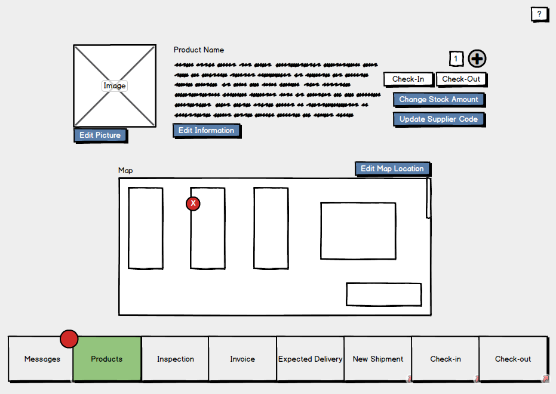

**Check out page**

This will be like a basket page seen on various shopping sites displaying a list of the products which the user wishes to checkout. Users will be able to remove items from this list, check the quality of the items and view their descriptions.

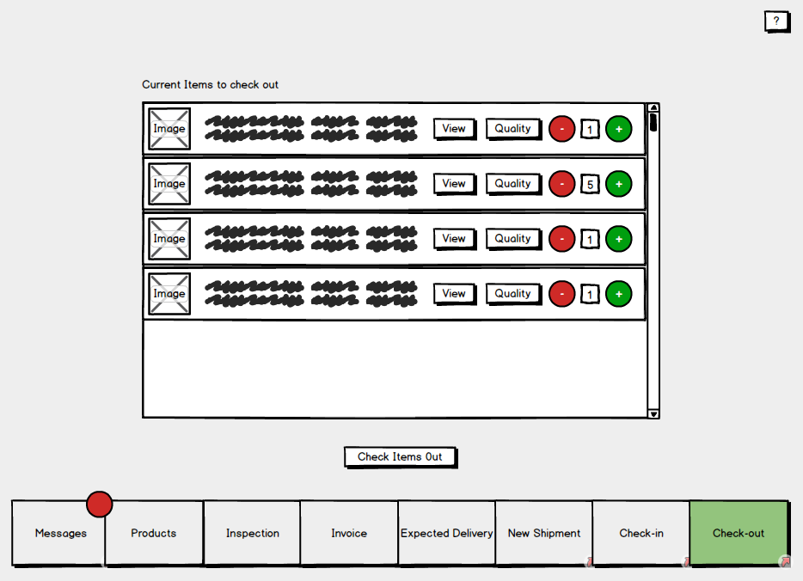

**Check-in page**

On this page staff will be able to search for a customer to see the items they have currently checked out. These items can be selected and checked back in. (This will send them either to the inspection database if it’s developed in time, or flag them as returned in stores)

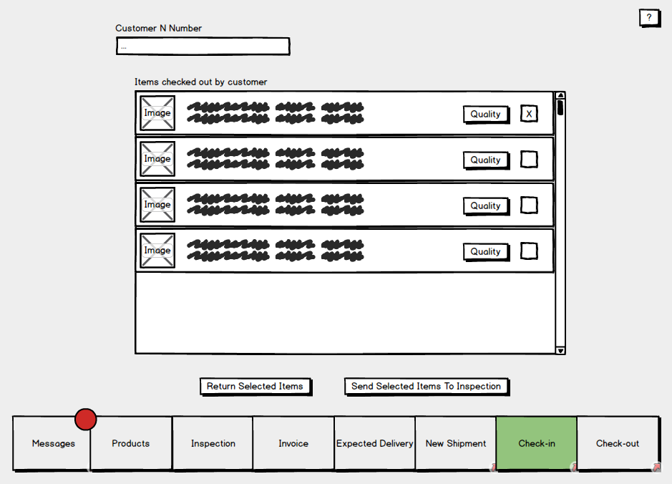

**Messages page**

The messages page will display messages for the logged in user. Categories of messages include; Overdue returns, products low on stock, expected shipments and expiring products.

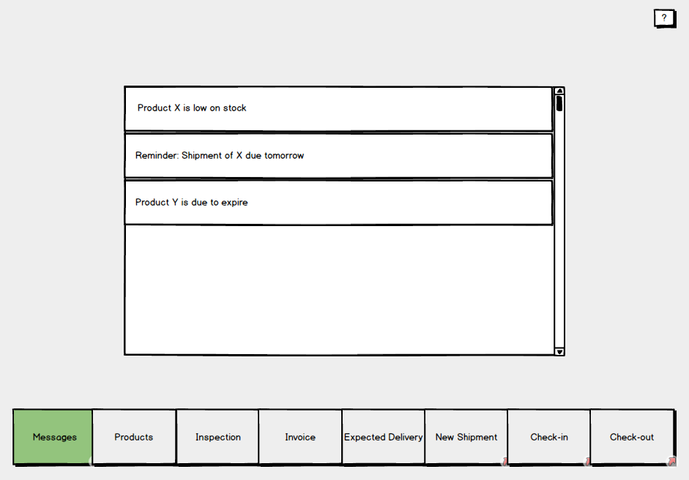

**New shipment pages**

This page, used by staff, is to enter information about an arrived shipment. Depending on weather the shipment is a repeat shipment the user will navigate to either the “Add brand new product” page or “Update stock shipment” page.

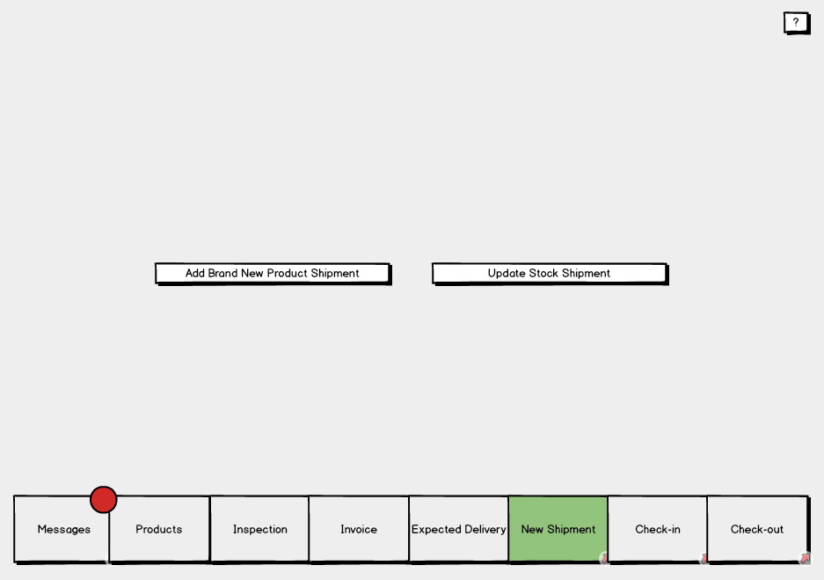

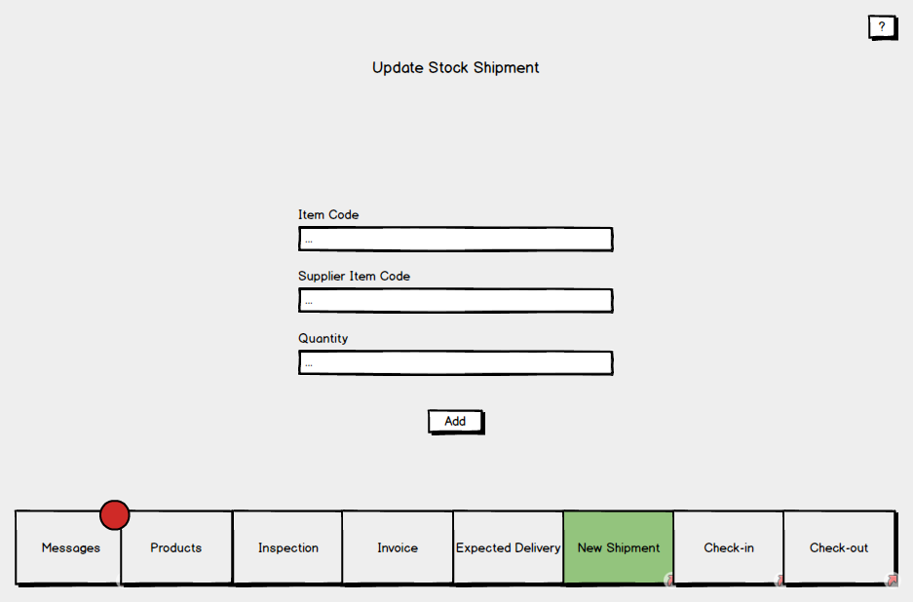

**Adding new shipments**

The process of adding new shipments is to be split up into two separate pages. First where shipment information is entered, and second where the items of the shipment are entered. These items will then be saved to stores.

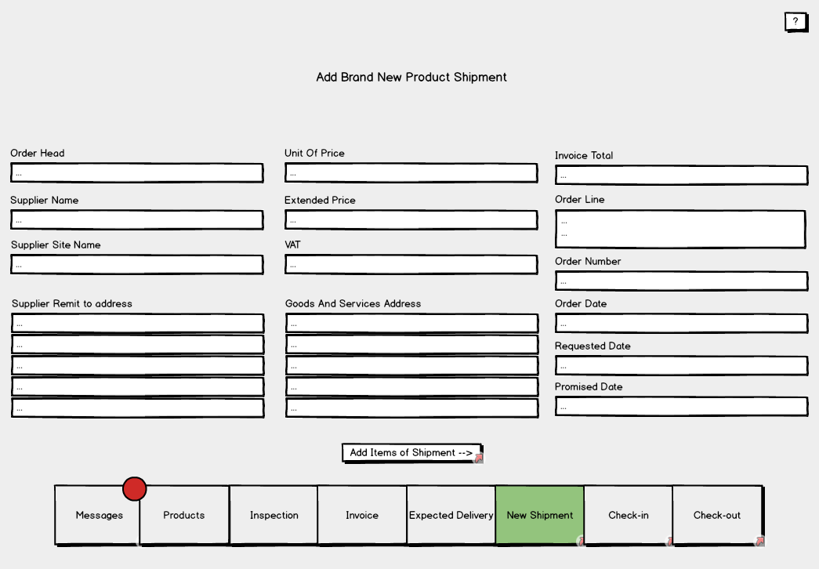

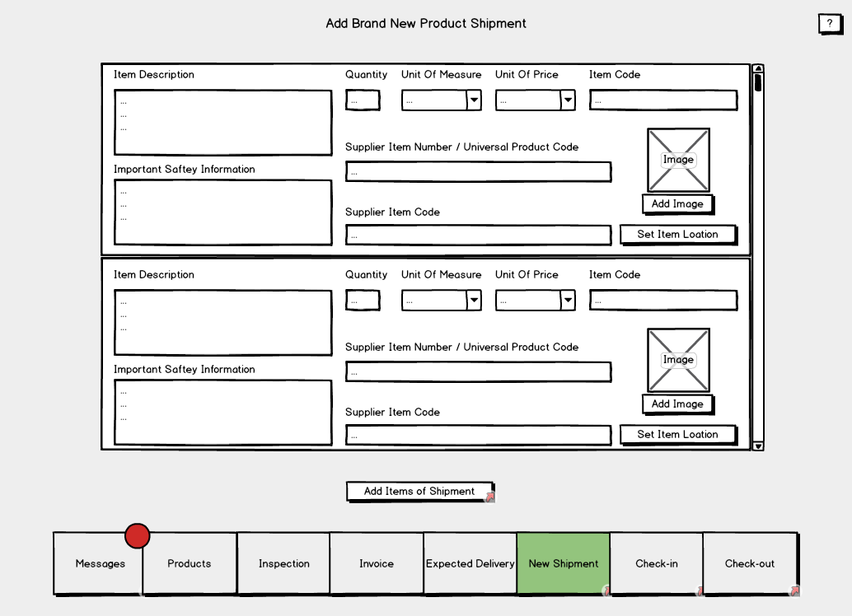

**Invoices page**

Two options are available on this page; A staff member can either add an invoice manually to be sent to a department, or, the invoice information can be filled in automatically from the systems invoice log.

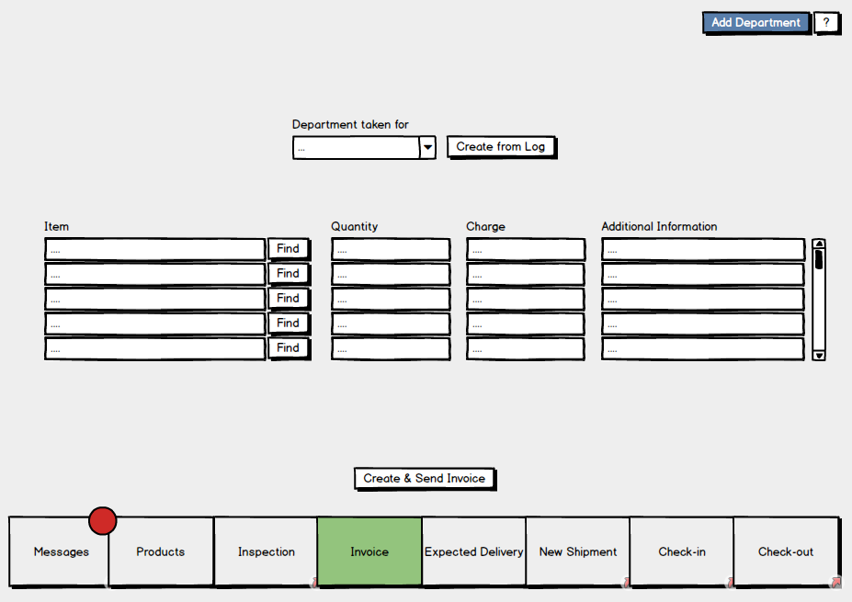

**Inspection page**

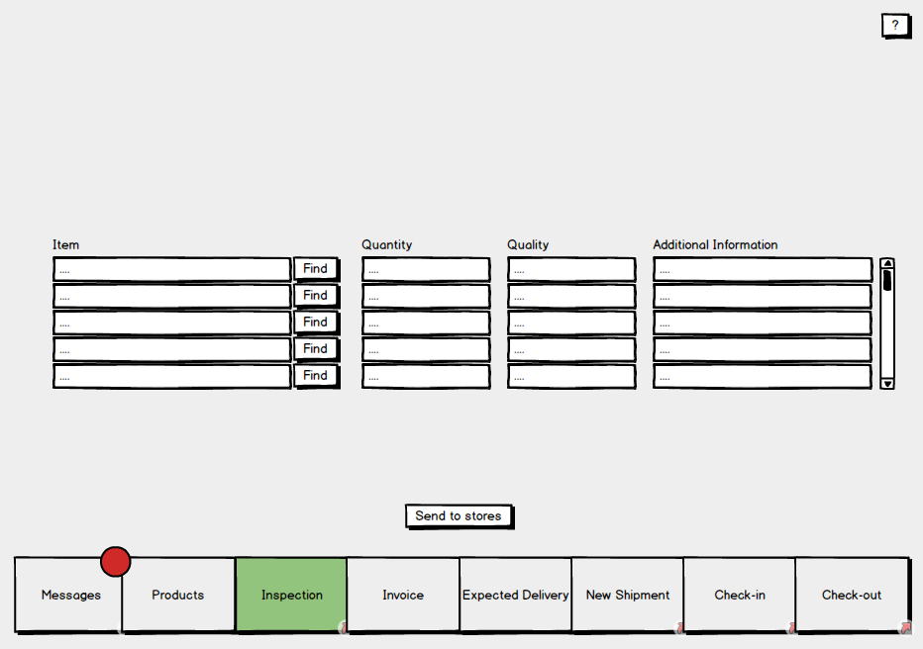

**3.2 Hardware interfaces**

Thanks to the system being software based there are only two hardware interfaces to be considered. Firstly, the systems interface with the barcode scanner, and secondly the interface between the system and computer on which it will run. Both interfaces will be used by staff, admins and customers.

**3.3 Software interfaces**

The diagram below illustrates the systems software interfaces.

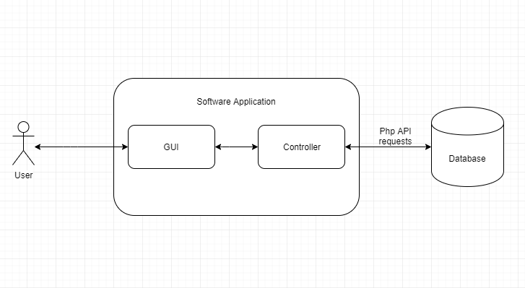

The systems interface with the database will be used to transfer data between the database and the system. This will include the retrieval and uploading of; products, user data, transactions and invoices. In order to achieve its functionality, the interface will make use of the internet via PHP API requests.

The systems backend will be linked via an interface to the GUI. This link will provide the user with a method of accessing the systems features.

# Use Case Modelling

## Use Cases

* Provide a summary of the major functions that the product will perform. Organize the functions to be understandable to the customer or a first-time reader. Include use cases and business scenarios or provide a link to a separate document (or documents). A business scenario:
* Describes a significant business need
* Identifies, documents, and ranks the problem that is driving the scenario
* Describes the business and technical environment that will resolve the problem
* States the desired objectives
* Shows the “Actors” and where they fit in the business model
* Is specific, and measurable, and uses clear metrics for success

## Misuse cases

* Provide some examples of functions that should not be possible to perform in the system. These may help you meet any security requirements you have.

# Project Plan:

This may be considered as separate from the rest of the document, as it is not concerned with the system, but how you are going to organise your team to build it.

Explain which agile methodology you will use, what tools you will use to track progress, source control etc.

Take a look at your interfaces and assign them “T-shirt sizes” (XS, S, M, L, XL).

The team would start by clearly writing job descriptions for each team member and making them available to every member of the team. Everyone has to know their areas of responsibility. To make a group of people feel like they belong to a large community, the team would introduce a number of team building activities so that everyone would get a chance to know each other in an informal way. Would not care about placing all team members in one location - telecommuting is perfectly fine in the contemporary world.

To foster collaboration, we would implement a specific type of organizational culture - clan culture - that would foster mentorship and team accountability. The teamwork combines individual commitment with group results, which makes it different from regular working groups, such as a function in a corporation. The team would select people into the team based on their transferable skills and skill potential, not for their personality (Principles of Management 499).

The team will work their ground rules by discussing expectations of collaboration, discipline, confidentiality matters, project approach, conflict resolution, to name a few. To set tasks and track performance, the team would equip the team members with a methodological framework and versatile tools. The framework would be scrum, one of the implementations of agile methodology. This framework supposes conducting everyday meetings mandatory for all team members where each member reads their tasks for the day, and the status of processed tasks is established. What is more important, everyone thinks of the ways they can help their colleagues succeed in fulfilling the daily tasks. In case the timeline gets challenged, the brainstorm for solutions is conducted. This way, the group would ensure the smooth work process of each employee and know whether they were available for new jobs.

To track working time on each task, as well as their status, the team would introduce Jira or Trello. New assignments would be in backlog; then they would be moved to in progress, then approval, later on - revision if necessary, and completion stages. These digital logs provide managers and employees with statistics regarding the productive time one works and allow predicting timeframes for upcoming projects.

Communication within the team would be conducted via emails, messengers, and video conferencing. Emails would be mainly for formal approvals and distributing minutes of meetings, messengers, such as WhatsApp, would serve as daily formal and informal communication channels; and video conferencing would be conducted in applications, such as Microsoft teams or Zoom. Storing files and regulating access to information is one of the paramount issues for a team manager. Since everyone has to have equal rights to files, secure storage has to be selected. Onedrive is one of the file hostings that allows uploading files, synchronizing the work of several people on a number of files in real-life mode.

Regarding the tools for building a system, GitHub proves to be an indispensable software development partner within the developers’ community. It encompasses code creation, integration, review, and overall team management. This way, the working processes are transparent, and each team member is easily replaceable. In case a new team member arrives, they will be able to seamlessly continue where the previous employee left.

Overall, team management is a challenging task. Leaders have to unite team members, supply them with measurable job descriptions, and equip with necessary tools for work. To remain productive, agile methodologies have to be welcomed. The crucial aspect is helping coworkers to reach mutual success.

Work Cited

References

## 

References here in Harvard referencing style. Use MS Word citing and referencing feature.

*Principles of Management*. Openstax. Roice University. (Came from project planning section, needs review)

Bibliography

## 

Bibliography here in Harvard referencing style.

(S Dhall & P Sundararaman, NA). C# AND .NET FRAMEWORK. <https://www.cs.colorado.edu/~kena/classes/5448/f12/presentation-materials/dhall.pdf>